Christus Lutheran Church

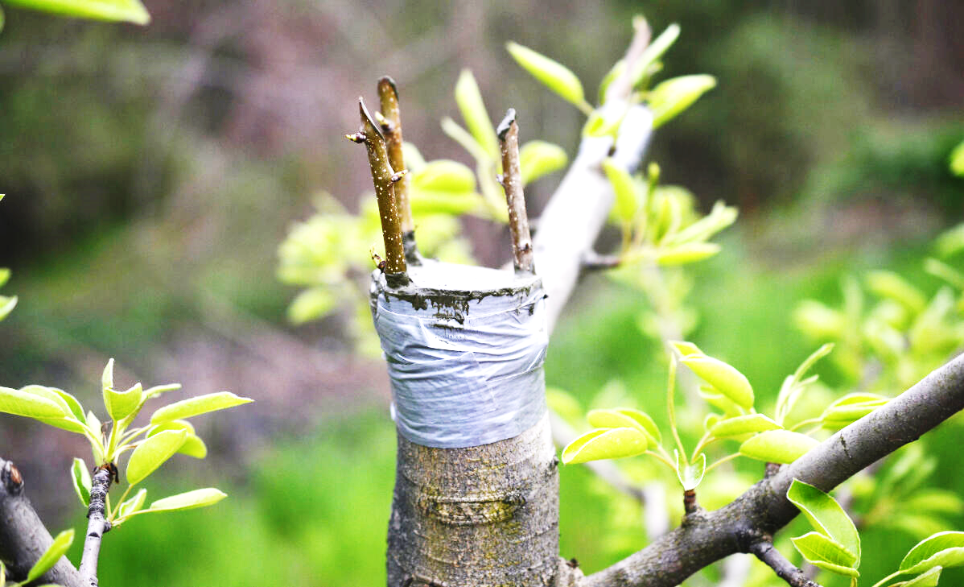

“Abide in me, and I in you. As the branch cannot bear fruit by itself, unless it abides in the vine, neither can you, unless you abide in me.”
John 15:4

Large Print 8:00 & 10:30
April 28, 2024
PRELUDE Ericka Shelton

WELCOME

INVOCATION
P: In the name of the Father, and of the Son, and of the Holy Spirit. C: Amen

CONFESSION & ABSOLUTION
Kneel as you are able, or remain seated
Silence to reflect on the sins that trouble us
P: Almighty God, our Creator, Redeemer, Sanctifier;
C: we poor sinners confess to you that, because of our fallen nature, we are utterly sinful; all our righteousness is like filthy rags. Convict us, and drive us to the cross of your beloved Son, where we see both the consequence and the forgiveness of our sins.
P: Your heavenly Father looks upon you in mercy, and for the sake of the suffering and death of his beloved Son, Jesus Christ, forgives you all your sins, and pours the Holy Spirit into your heart that you may live a new life.
C: Amen. Thanks be to God through our Lord Jesus Christ.

Stand
PEACE

P: The grace of our Lord Jesus Christ be with your spirit. C: And with your spirit. (Galatians 6:8)

Stand
HYMN: Rise, O Children of Salvation LBW #182

1 Rise, O children of salvation,
All who cleave to Christ the head!
Wake, awake, O mighty nation,
Lest the foe on Zion tread;

He draws nigh and would defy
All the hosts of God Most High.

2 Saints and martyrs long before us
Firmly on this ground have stood;
See the banner waving o’er us,
Conquror’s through the Savior’s blood.
Ground we hold, where on of old
Fought the faithful and the bold.

3 Fighting, we shall be victorious
by the blood of Christ our Lord;
On our foreheads, bright and glorious,
Shines the witness of his Word;
Spear and shield on battlefield,
His great name; we cannot yield.

4 When his servants stand before him,
Each receiving his reward;
When his saints in light adore him,
Giving glory to the Lord;
“Victory!” our song shall be,
Like the thunder of the sea.

PRAYER OF THE DAY
P: The Lord be with you.
C: And also with you.
P: Let us pray. God, the Father of our Lord Jesus Christ;
C: as branches grafted to Christ the true vine, fill us with His life; prune away whatever hinders growth; and make us fruitful, to the benefit of our neighbor and to your everlasting glory; through Christ our Lord. Amen

Be Seated

FIRST LESSON: Acts 8:26-40
R: The first lesson is from the book of Acts, the 8th chapter.
²⁶ Now an angel of the Lord said to Philip, “Rise and go toward the south to the road that goes down from Jerusalem to Gaza.” This is a desert place. ²⁷ And he rose and went. And there was an Ethiopian, a eunuch, a court official of Candace, queen of the Ethiopians, who was in charge of all her treasure. He had come to Jerusalem to worship ²⁸ and was returning, seated in his chariot, and he was reading the prophet Isaiah. ²⁹ And the Spirit said to Philip, “Go over and join this chariot.” ³⁰ So Philip ran to him and heard him reading Isaiah the prophet and asked, “Do you understand what you are reading?” ³¹ And he said, “How can I, unless someone guides me?” And he invited Philip to come up and sit with him. ³² Now the passage of the Scripture that he was reading was this:
“Like a sheep he was led to the slaughter and like a lamb before its shearer is silent, so he opens not his mouth. ³³ In his humiliation justice was denied him. Who can describe his generation? For his life is taken away from the earth.”
³⁴ And the eunuch said to Philip, “About whom, I ask you, does the prophet say this, about himself or about someone else?” ³⁵ Then Philip opened his mouth, and beginning with this Scripture he told him the good news about Jesus. ³⁶ And as they were going along the road they came to some water, and the eunuch said, “See, here is water! What prevents me from being baptized?” ³⁸ And he commanded the chariot to stop, and they both went down into the water, Philip and the eunuch, and he baptized him. ³⁹ And when they came up out of the water, the Spirit of the Lord carried Philip away, and the eunuch saw him no more, and went on his way rejoicing. ⁴⁰ But Philip found himself at Azotus, and as he passed through he preached the gospel to all the towns until he came to Caesarea.
R: The Word of the Lord
C: Thanks be to God

SECOND LESSON: 1 John 4:7-19
R: The second lesson is from 1 John, the 4th chapter
⁷ Beloved, let us love one another, for love is from God, and whoever loves has been born of God and knows God. ⁸ Anyone who does not love does not know God, because God is love. ⁹ In this the love of God was made manifest among us, that God sent his only Son into the world, so that we might live through him. ¹⁰ In this is love, not that we have loved God but that he loved us and sent his Son to be the propitiation for our sins. ¹¹ Beloved, if God so loved us, we also ought to love one another. ¹² No one has ever seen God; if we love one another, God abides in us and his love is perfected in us.
¹³ By this we know that we abide in him and he in us, because he has given us of his Spirit. ¹⁴ And we have seen and testify that the Father has sent his Son to be the Savior of the world. ¹⁵ Whoever confesses that Jesus is the Son of God, God abides in him, and he in God. ¹⁶ So we have come to know and to believe the love that God has for us. God is love, and whoever abides in love abides in God, and God abides in him. ¹⁷ By this is love perfected with us, so that we may have confidence for the day of judgment, because as he is so also are we in this world. ¹⁸ There is no fear in love, but perfect love casts out fear. For fear has to do with punishment, and whoever fears has not been perfected in love. ¹⁹ We love because he first loved us.
R: The Word of the Lord
C: Thanks be to God

CHILDREN’S MESSAGE

Stand
GOSPEL LESSON: John 15:1-8
P: The Holy Gospel, according to St. John the 15th chapter
C: Glory to you, O Lord
¹ “I am the true vine, and my Father is the vinedresser. ² Every branch in me that does not bear fruit he takes away, and every branch that does bear fruit he prunes, that it may bear more fruit. ³ Already you are clean because of the word that I have spoken to you. ⁴ Abide in me, and I in you. As the branch cannot bear fruit by itself, unless it abides in the vine, neither can you, unless you abide in me. ⁵ I am the vine; you are the branches. Whoever abides in me and I in him, he it is that bears much fruit, for apart from me you can do nothing. ⁶ If anyone does not abide in me he is thrown away like a branch and withers; and the branches are gathered, thrown into the fire, and burned. ⁷ If you abide in me, and my words abide in you, ask whatever you wish, and it will be done for you. ⁸ By this my Father is glorified, that you bear much fruit and so prove to be my disciples.
P: The Gospel of our Lord
C: Praise to you, O Christ
Be Seated

SERMON

Stand
HYMN: O Blessed Spring tune LBW 475

1 O blessed spring, where Word and sign
embrace us into Christ the Vine:
Here Christ enjoins each one to be
a branch of this life-giving Tree.

2 Through summer heat of youthful years,
uncertain faith, rebellious tears,
Sustained by Christ’s infusing rain,
the boughs will shout for joy again.

3 When autumn cools and youth is cold,
When limbs their heavy harvest hold,
Then through us, warm, the Christ will move
with gifts of beauty, wisdom, love.

4 As winter comes, as winters must,
We breathe our last, return to dust;
Still held in Christ, our souls take wing
and trust the promise of the spring.

5 Christ, holy Vine; Christ, living Tree;
Be praised for this blest mystery:
That Word and water thus revive
and join us to your Tree of Life.

NICENE CREED
P: Together with the saints of all times and places, we confess the one, true faith, using the words of the Nicene Creed: C: We believe in one God, the Father, the Almighty, maker of heaven and earth; of all that is, seen and unseen.
We believe in one Lord, Jesus Christ, the only Son of God, eternally begotten of the Father; God from God, Light from Light, True God from True God; begotten, not made; of one Being with the Father. Through him all things were made. For us and for our salvation, he came down from heaven; by the power of the Holy Spirit, he became incarnate from the virgin Mary, and was made man. For our sake, he was crucified under Pontius Pilate; he suffered death and was buried. On the third day he rose again, in accordance with the Scriptures; he ascended into heaven, and is seated at the right hand of the Father. He will come again in glory to judge the living and the dead, and his kingdom will have no end.
We believe in the Holy Spirit; the Lord, the giver of life, who proceeds from the Father and the Son. With the Father and the Son he is worshiped and glorified. He has spoken through the prophets. We believe in one, holy, catholic and apostolic Church. We acknowledge one baptism for the forgiveness of sins. We look for the resurrection of the dead, and the life of the world to come. Amen

Be Seated
PRAYERS OF THE CHURCH

OFFERING

Stand
OFFERTORY PRAYER
P: Let us pray. Heavenly Father,
C: you have entrusted us with many things. Help us to be true stewards of them all, that we and many may enjoy the bounty you promise your children; through Jesus Christ our Lord. Amen

THE LORD’S SUPPER
WORDS OF INSTITUTION
LORD’S PRAYER
DISTRIBUTION
Stand
POST-COMMUNION BLESSING

ANNOUNCEMENTS

BENEDICTION
P: The Lord bless you and keep you; the Lord make his face to shine on you and be gracious to you; the Lord lift
his countenance upon you and give you peace; in the
name of the Father, and the Son and the Holy Spirit.
C: Amen

HYMN: Lead On, O King Eternal! LBW #495

1 Lead on, O King eternal!
The day of march has come;
Hence-forth in fields of conquest
Your tents will be our home.
Through days of preparation
Your grace has made us strong;
And now, O King eternal,
We lift our battle song.

2 Lead on, O King eternal!
Till sin’s fierce war shall cease,
And holiness shall whisper
The sweet amen of peace;
For not with swords loud clashing,
Nor roll of stirring drums,
But deeds of love and mercy
The heav’nly kingdom comes.

3 Lead on, O King eternal!
We follow, not with fears,
For gladness breaks like morning
Where-e’er your face appears.
Your cross is lifted o’er us;
We journey in its light;
The crown awaits the conquest;
Lead on, O God of might!

DISMISSAL
P: We go in peace, to fear God, love God, and trust God.
C: He is to be feared and loved, and He can be trusted. Amen

POSTLUDE Ericka Shelton

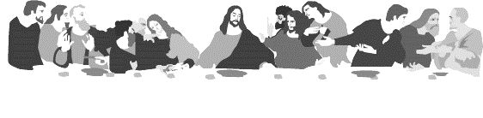
HOLY COMMUNION
All the baptized who believe in the true presence of Christ
in these elements, the bread and wine,
and who know their need of forgiveness,
are welcome to receive the Lord’s Supper.
(1 Cor. 11:23-25; Matt.26:26-28; Mark 14:22-24; Luke 22:19, 20)

Both wine (red) and grape juice (white) are available.
Gluten-free wafers are available – please ask your server for the gluten free wafer if you so choose.
Children who have not received instruction, and those who do not believe in the true presence of Christ in the Supper, may come forward with arms crossed over their hearts to receive a blessing.

Our mission is to invite people of all nations
into fellowship with Jesus Christ,
and to make them His disciples
through preaching and teaching Christ crucified, risen
and coming again as the only hope of eternal salvation.

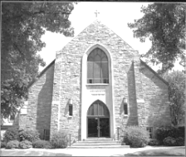
Christus Lutheran Church
120 N. Main St. Clintonville, WI 54929
(715) 823-6521 ● christus@charter.net ●
www.christusclintonville.org
Pastors: Brian Crocker & Shelly Klemp

